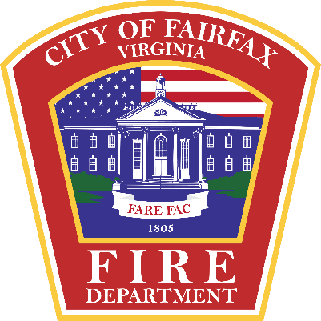 | Code Administration/ Fire Marshal’s Office  City of Fairfax Fire Department  10455 Armstrong St Fairfax, VA 22030  703-385-7830

Code Requirements for Tents and Temporary Membrane Structures
Rev. 12/2017 (VASFPC 2012)

TENT. A structure, enclosure, or shelter, with or without sidewalls or drops, constructed of fabric or pliable material supported by any manner except by air or the contents that it protects.

MEMBRANE STRUCTURE. An air-inflated, air-supported, cable- or frame-covered structure as defined by the Virginia Uniform Statewide Building Code (USBC) and not otherwise defined as a tent.

Temporary Tents, air supported, air inflated, or tensioned membrane structures shall not be erected for a period of more than 180 days within a 12-month period on a single premises.

An operational permit is required to operate an air-supported temporary membrane structure or a tent.

Permit Required
- Tents (with or without sides) larger than 900 sqft
- Occupancy is more than 50 people
  - Occupancy requirement will depend on if the guests are standing, if there are chairs or if there are people seated at tables
- Tents or membrane structures larger than 400sqft with or without sides (regardless of whether or not they are in use, i.e. “the sides will remain up unless it rains”)
- Multiple tents side-by-side without a fire break clearance of 12 ft and aggregate area of more than 700 sqft
- Occupant load of greater than 50 or more persons regardless of tent size. How will the tent be used? Tables and chairs, chairs, standing room only, or is there a dance floor?

Exceptions
- Tents used exclusively for recreational camping purposes.

- Tents or membrane structures shall not be located within 20 ft of lot lines, buildings, vehicular traffic, or internal combustion engines (generators, vehicles, fueled equipment)
- The tent roof material must have a label attached to the fabric to indicate that it has been fire retardant treated. This same label must also be attached to all tent side panels.
- At least one portable fire extinguisher with a minimum 4-A rating, or two portable fire extinguishers with a minimum 2-A rating each, shall be provided in all tents or air-supported structures.
- Gasoline, propane, charcoal or any other cooking device, or any unapproved open flame shall not be permitted inside or located with 20 feet of the tent or air supported structure.
- Hay, straw, shavings or similar combustible materials shall not be located within any tent or air-supported structure containing an assembly occupancy, except the materials necessary for the daily feeding and care of animals. Sawdust and shavings utilized for a public performance or exhibit shall not be prohibited, provided the sawdust and shavings are kept damp. Combustible materials shall not be permitted under stands or seats at any time. The areas within, and adjacent to the tent or air-supported structure, shall be maintained clear of all combustible materials or vegetation that will create a fire hazard within 20 feet from the structure. All combustible trash shall be removed at least once a day from the structure during the period the structure is occupied by the public.
- All tents which have enclosing sides shall have approved exits. The exit openings shall remain open unless covered with flame-resistant curtains which are free sliding on a metal support or utilize approved doors. Where the occupant load is more than 50 and less than 199, two approved independent exits shall be maintained. Each exit shall be designated with an approved exit sign and emergency egress lighting. Tents with an occupant load of 200 or more will require additional exits.
- Any electrical wiring for lighting or other equipment within a tent requires an electrical permit.
- Where tables, chairs, or other equipment are installed in a tent, aisles and aisle access paths must be maintained.
- All tents shall be anchored per the manufacturer’s installation instructions, to resist wind and/or other loads.
- Smoking shall not be permitted in tents or membrane structures.

