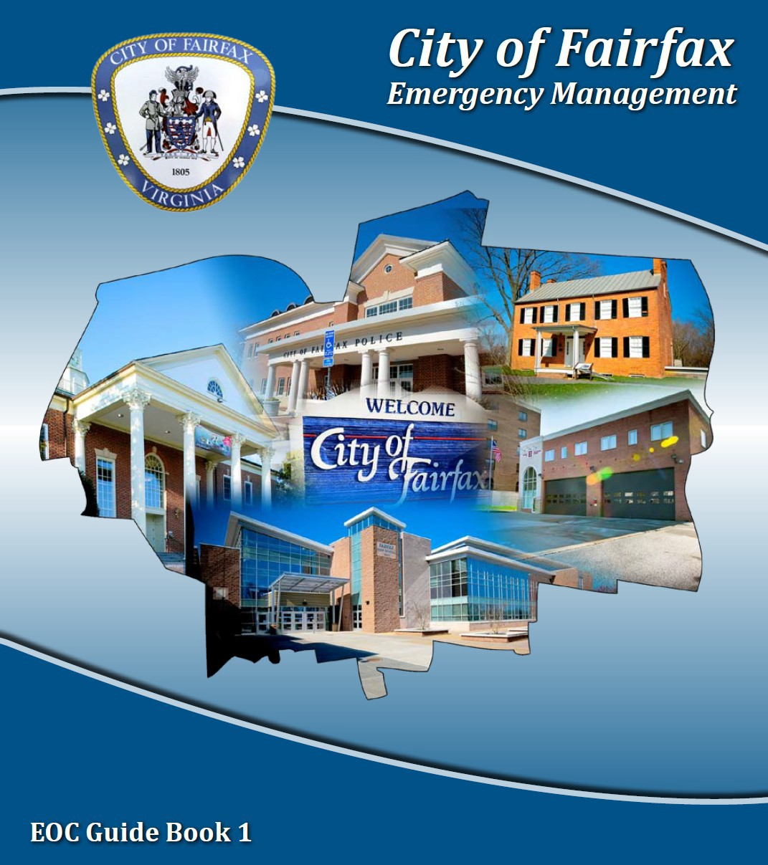

***Model Emergency Operations Plan for Houses of Worship***

Emergencies can occur quickly and without warning, and they can have a devastating impact on affected individuals, businesses, and community facilities. The information presented here is intended to provide guidelines on the development of a comprehensive emergency operations plan for places of worship in response to both common and uncommon hazards the City of Fairfax may face. In some cases, specific courses of action based on a certain type of incident are recommended. The model plan uses some of the best practices and lessons learned from across the Nation to increase overall safety and reduce the potential for further harm.

The City has developed this model in the hope that churches, synagogues, temples, mosques,and other places of worship within the community will take a proactive approach in preparing for an emergency and will make their congregants and visitors’ safety a priority.

#### Definitions

**Assumption.** A pre-identified statement of fact or hypothesis that may impact how a plan is implemented and/or activated.

**Authorities and References.** The laws, regulations, and references that support the facility’s emergency operations plan and the authority to develop and implement the plan.

**Direction and Control.** The basis for decision making and identification of who has the authority to make decisions for the facility.

**Lockdown.** Enhanced security measures taken to protect against potentially violent intruders inside the building. Instructions for lockdowns include:

* Stay in place within the building.
* Remain in locked rooms, away from windows, and unobservable (lights off, blinds drawn, door windows obscured with paper, etc.).
* Disregard fire alarms.

*This document was prepared under a grant from the Federal Emergency Management Agency’s Grant Programs Directorate (FEMA/GPD) within the U.S. Department of Homeland Security. Points of view or opinions expressed in this document are those of the authors and do not necessarily represent the official position or policies of FEMA/GPD or the U.S. Department of Homeland Security.*

## This page intentionally left blank

Contents

Introduction 1

*Purpose* 1

*Facility Information* 1

*Organization* 2

*Assumptions* 2

*Authorities and References* 3

Hazard Analysis 3

Concept of Operations 4

*Direction and Control* 4

*Notification* 4

*Medical Emergency* 5

*Evacuation* 6

*Re-Entry Following Evacuations* 6

*Sheltering* 7

*Intruder/Active Shooter Incident* 8

*Earthquakes* 8

*Recovery* 9

Continuity of Operations 9

Information, Training, and Exercises 10

Plan Maintenance 11

Annexes 12

## This page intentionally left blank

# Introduction

### *Purpose*

An emergency that involves the [Church NAME] could impact the business operations of the church, cause physical damage to the facilities, disrupt daily and/or weekly activities, and threaten the church’s ability to serve its congregants and the community.

In this section, provide an introduction to the plan which describes:

1. Purpose of the document (document processes and procedures for the timely and efficient response to emergencies)
2. Time of implementation (In anticipation of, or in response to an emergency or incident impacting the church facility)
3. Desired outcome that will be achieved through the planning process (Being prepared and understanding what to do in various types of emergencies can reduce anxiety, fear, and losses that may occur.)

### *Facility Information*

In this section, provide basic information concerning the facility to include:

* 1. Name of facility, address, telephone number, emergency contact telephone number and pager number if available, and fax number.
  2. Owner of facility and his or her address and telephone number.
  3. Year facility was built, type of construction, and date of any subsequent construction.
  4. Name of pastor/minister or other faith leader, address, work/home/mobile telephone number of his/her alternate, emergency after hours contact information.
  5. If there is a church school collocated at the facility, provide the name of church school director/administrator, address, work/home/mobile telephone number of his/her alternate, and emergency after-hours contact information.
     1. Is the church school emergency response plan separate from this plan?
     2. If separate, are the plans coordinated? (For example, are evacuation assembly points for church separate from the church school to maintain student safety and accountability?)
  6. Provide listing of primary and alternate points of contact for all non-church groups who regularly use the facility for meetings, such as Boy Scouts, Girl Scouts, and support groups. Include organization name; primary and alternate point of contact names; home/mobile phone numbers; and scheduled meeting dates, times, and locations within the facility.
  7. Provide an organizational chart, including phone numbers, with key staff positions identified.
  8. Provide any other information concerning the facility that has bearing on the implementation of this plan.
     1. Type of security alarm system and location of security alarm panel
     2. Type of fire alarm system and location of fire alarm panel
     3. Facility access procedures to include areas with controlled access, such as use of doorbells, or other notification devices, during off-hours

### *Organization*

In this section provide basic information concerning the church organization and its role in emergency response to include:

1. Pastor and church staff
2. Church committees or safety response team
3. Lay personnel – Sunday school teachers, ushers, wedding coordinator, etc.
4. Church school personnel
5. Non-church group leaders (Boy Scouts, support groups, etc.)

### *Assumptions*

An **assumption** is a pre-identified statement of fact or hypothesis that may impact how a plan is implemented and/or activated. Under this header, include situations or conditions that are assumed to be true in the absence of positive proof. This step is necessary in the planning process to enable the leader to complete an estimate of the situation and make a decision on the course of action.

The following assumptions with regard to disaster emergency situations may be made:

*(These examples may be used and are not listed in priority order.)*

1. An emergency or disaster (a natural, manmade, or national security event) can affect the [Facility NAME] at any time.
2. A hurricane, tornado, wind storm, electrical storm, severe ice storm, or blizzard affecting the [Facility NAME] can cause the loss of power, telephone service, and other utilities and result in a major threat to facility operations and the health and safety of people within the [Facility NAME].
3. Some advance warning may be received before natural and manmade disasters occur. Thunderstorms that produce dangerous winds and tornadoes may appear with little advance warning.
4. Incidents may occur at times when non-church groups, who may not be aware of the specifics of this emergency operation plan, are using the facility.
5. Incidents may affect the church facility that limit immediate support to congregants and the community.

### *Authorities and References*

***Authorities and References*** present the laws, regulations, and references that support the facility’s emergency operations plan and the authority to develop the plan and implement it. The list below includes examples of authorities and references commonly found in similar types of facilities; however, additional authorites may apply.

1. Virginia Fire Prevention Code (fire evacuation planning)
2. Church denomination authorities, guidelines, or regulations
3. Guide for Developing High-Quality Emergency Operations Plans for Houses of Worship, FEMA, June 2013
4. Community Crisis Guide, City of Fairfax Office of Emergency Management

# Hazard Analysis

Under this header, describe the potential hazards to which the facility is vulnerable, such as hurricanes, tornadoes, flooding, fires, hazardous materials incidents from fixed facilities or transportation accidents, proximity to a nuclear power plant, power outages during severe cold or hot weather, or other dangers. Explain history and lessons learned from such incidents.

Examples of information to include in this section are:

1. Type, number, and use of buildings within the facility/complex (e.g., church/sanctuary, education building, youth activities building, etc.)
2. Identification of flood zone for each facility as identified on a Flood Insurance Rate Map (this may or may not be applicable for all facilities)
3. Proximity of facility to a railroad or major transportation artery (per hazardous materials incidents)
4. Identify if facility is located in close proximity to hazardous facilities (such as Pickett Road Tank Farm, etc.)

# Concept of Operations

This section of the plan defines the policies, procedures, responsibilities, and actions that the facility will take before, during, and after any emergency situation. At a minimum, the facility plan needs to address: direction and control; notification; medical incidents; evacuation;

re-entry; sheltering; intruder/active shooter incidents; earthquakes; and recovery.

### *Direction and Control*

**Direction and control** provides a basis for decision making and identifies who has the authority to make decisions for the facility. This section describes the church or other religious facility’s management function for emergency operations. Examples of information in this section include:

1. Identify, by title, who is in charge during an emergency, and one alternate leader, in the event that person is unable to serve in that capacity. (This may be a non-church member, such as a Boy Scout troop leader, who is the most qualified to make decisions.)
2. Identify key positions during emergency incidents and how they will be staffed.
3. State how coordination will occur between the church school facilities and other church facilities during times of emergency.
4. Describe processes and procedures for implementing a continuity of operations plan, as warranted.

### *Notification*

Procedures must be in place for the facility to receive timely information on impending threats, so that facility decision makers, staff, congregants, and facility users are alerted of potential emergency conditions.

This section describes how the church or place of worship receives emergency warnings and notifications as well as the procedures for alerting staff and congregants of these warnings. Examples of information for this section include:

1. Define how the facility will receive warnings at all times,including during normal business operations, worship services, off hours, weekends, and holidays. (National Oceanic and Atmospheric Administration [NOAA] Weather Radio, City of Fairfax Emergency Message Alert System [eMAS], etc.)
2. Define how key staff will be alerted.
3. Define how congregants and/or facility users will be alerted and the precautionary measures that will be taken.
4. List alternative means of notification should the primary system fail.

### *Medical Emergency*

For all life-threatening emergencies, **dial 911**. The dispatch center will send an ambulance and other emergency responders as necessary. Types of life-threatening emergencies include thermal burns, chemical burns, head or spinal injuries, unconsciousness, choking, trouble breathing, suspected heart attack, severe bleeding, seizure, heat emergencies, hypothermia, and bone or joint injuries such as fractures, sprains, and dislocations.

In this section, describe the policies, roles, responsibilities, and procedures for the response to medical emergencies. Sample information includes:

1. Describe policies and procedures for the response to medical emergencies, to include:
   1. Incidents during church-sponsored events (worship, meetings, etc.)
   2. Incidents involving youth (permissions, accountability, etc.)
   3. Incidents involving external groups that use the facility for meetings and other events
2. List the procedures for notifying church leadership when a medical emergency occurs at the facility, particularly if emergency medical services are called or the incident involves an outside organization.
3. List location(s) of first aid kits within the facility. (Display on map in Annex of this plan)
4. List location(s) of automated external defibrillators (AED) within the facility. (Display on map in Annex of this plan)
5. Identify staff/congregants trained in first aid (or higher), CPR, and the use of the AED.

### *Evacuation*

Evacuation refers to the orderly exit of all persons from the facility as a result of fire or other emergency. The Virginia Fire Prevention Code requires the development and posting of evacuation routes for all public facilities, including churches. In addition to these evacuation routes, policies and procedures are required to ensure the effective and efficient evacuation of the facility in the event of an emergency.

This section describes the policies, roles, responsibilities, and procedures for the evacuation of the facility. Examples of the information required in this section include:

1. Describe the policies and procedures for the evacuation of the facility due to fire or other type of emergency.
2. List the roles and responsibilities of staff/lay personnel during evacuations, such as school teachers, ushers, and greeters.
3. List the assembly points outside of the building and primary and secondary exit routes to those points from all portions of the building(s) to complete an evacuation of the building. Coordinate assembly points with those identified for use by the church school to ensure no duplication occurs for the safety, security, and accountability of the students and staff.
4. List the procedures for ensuring the safe, orderly, and effective evacuation of children and individuals with functional needs.

### *Re-Entry Following Evacuations*

Once a facility has been evacuated, procedures need to be in place for allowing staff, congregants, and visitors to re-enter the facility. Re-entry to the facility should occur only upon authorization from a designated official of the facility and only to those parts of the facility deemed safe.

In this section, describe the policies, roles, responsibilities, and procedures for re-entry of the facility following evacuations. Examples of the information required in this section include:

1. Identify the responsible person(s) for authorizing re-entry to an affected location, and his or her title(s).
   1. Coordinate re-entry decision with on-scene emergency response officials, as appropriate (for example, fire and police departments).
   2. Determine if re-entry to the facility includes:
      1. Full-facility occupancy; normal operations
      2. Full-facility occupancy; limited operations
      3. Partial facility occupancy; limited operations
      4. Re-entry to retrieve critical/personal items only (purses, critical/valuable religious assets or artifacts)
2. List the procedures for inspection of the facility to ensure it is structurally sound.
3. List the procedures for controlling facility entrances to limit re-entry to authorized personnel based on the situation.

### *Sheltering*

Sheltering refers to short-term protection or refuge within the church facility because of severe weather such as a tornado, and a shelter-in-place order due to a hazardous materials incident.

**Severe Weather/Tornados**. In the event of a tornado, seek shelter in the lowest possible level of the building you are in. Stay away from windows and doors. Seek shelter in the designated areas.

**Shelter-In-Place.** Sheltering-in-place may be required temporarily in order to prevent or reduce exposure to hazardous outdoor atmospheres, such as incidents involving a hazardous materials release. In such an event, an announcement will be made by public officials using a public address system, reverse-911, local media including television and/or radio, as well as alerts from social media sources such as Facebook and Twitter.

In this section, describe the policies, roles, responsibilities, and procedures for the short-term sheltering-in-place of staff, congregants, and visitors within the facility during designated emergencies. Sample information for this section includes:

1. Describe policies and procedures for sheltering-in-place as a result of severe weather or other type of emergency, to include the decision to shelter-in-place and when to declare an “all clear” from shelter-in-place operations.
2. List the roles and responsibilities of staff/lay personnel during sheltering-in-place, such as school teachers, ushers, and greeters.
3. List the protected spaces within the facility suitable for sheltering-in-place from severe weather/tornadoes and other emergencies, such as hazardous materials.
4. Describe the location and procedures for turning off the air conditioner and/or heating system to prevent outside contaminants from entering the facility in the event of a chemical release.
5. List the procedures for ensuring the safe, orderly, and effective movement of children and individuals with mobility issues to designated safe areas.
6. Describe the process used to verify and maintain accountability of staff, congregants, and visitors, such as children or other groups that may hold meetings at the facility.

### *Intruder/Active Shooter Incident*

This section includes situations where an intruder or active shooter is in the immediate area of the church property or has gained access to the church facility. These types of incidents are unpredictable and evolve quickly. Individuals must be prepared to react to an active shooter situation prior to the arrival of law enforcement.

In this section, describe the policies, roles, responsibilities, and procedures for incidents involving an intruder or an active shooter. Examples of information for this section of the plan include:

1. Describe the policies and procedures for the response to an intruder/active shooter situation, to include alerting staff and visitors to the threat and notifying them of the all- clear signal.
2. List the roles and responsibilities of staff/lay personnel during intruder/active shooter incidents, such as school teachers, ushers, and greeters.
3. Describe the facility lockdown process so entry and exit to all parts of the facility can be controlled. List when and how this process was tested.
4. Describe the process to minimize and control points of access and exit in buildings and areas without use of lockdown procedures.

### *Earthquakes*

Earthquakes are rare events in Virginia, but as witnessed in August 2011, not unprecedented. When an earthquake does occur, take cover; DUCK under a sturdy desk, table, pew, or other furniture. If that is not possible, seek COVER against an interior wall and protect your head and neck with your arms. Avoid danger spots near windows, hanging objects, mirrors, or tall unsecured furniture. If you take cover under a sturdy piece of furniture, HOLD on to it and be prepared to move with it. Hold until the ground stops shaking and it is safe to evacuate.

This section describes the policies, roles, responsibilities, and procedures for the protection of congregants and visitors to the facility in the event of an earthquake. Examples include:

1. Describe the policies and procedures for the response to earthquakes.
2. List the roles and responsibilities of staff/lay personnel, such as school teachers, ushers, and greeters during earthquakes.
3. List the assembly points outside of the building and primary and secondary exit routes to those points from all portions of the building(s) to complete an evacuation of the building. Coordinate assembly points with those identified for use by the church school to ensure no duplication occurs for the safety, security, and accountability of the students and staff.
4. Describe the procedures for ensuring the safe, orderly, and effective evacuation of children and those with functional needs.

### *Recovery*

Disaster may strike the church facilities only (fire) or may be part of a wider path of destruction (tornado or flood) that impacts the congregants’ homes and businesses as well. Depending on the situation, recovery can last days or weeks, months, and in some cases, years. Churches rely on their congregants to volunteer their time, talents, and money to support and/or operate the church on a daily basis. This reliance may be hindered when a large number of congregants are personally affected by the incident as well.

In this section, describe the policies, roles, responsibilities, and procedures for recovering from an emergency or disaster, to include non-church groups that use the facility. Examples include:

1. Describe the roles and responsibilities of the organization, including leadership and church committees, regarding recovery activities.
2. List the policies and procedures for conducting a damage assessment of church facilities and assets, in conjunction with local officials.
3. Describe procedures for coordinating with utilities and insurance carriers following a disaster.
4. Describe how recovery priorities will be developed and determined:
   1. In what order are services reconstituted (for example, worship, church school, homeless feeding and shelter program)?
   2. Use of temporary space, if available
   3. Restoration of church artifacts and critical assets
5. List how the church might provide immediate, short-, and long-term emotional and psychological counseling and support to its congregants, as well as the community at large, following a disaster when church facilities have been affected by the disaster.

# Continuity of Operations

The community relies on a church for many things beyond spiritual counseling to support its residents. In addition to weekly worship services, churches may offer school, day care, feeding and sheltering for the homeless, and meeting space for groups such as Alcoholics Anonymous and Boy and Girl Scouts. What programs or services **must** continue despite physical damage to church facilities? What programs can be placed on hold until facilities

are recovered? How will the church maintain operations of these high priority or essential functions during and after a disaster?

This section should identify the processes, procedures, roles, and responsibilities for the continuity of operations of the church’s essential functions during and following a disaster. Examples include:

1. Describe the roles and responsibilities of the organization, including leadership, administrative, and church committees regarding continuity of operations.
2. List the functions/services of the church and the continuity priority assigned to each.

For example:

* 1. Continuing weekly worship may be an essential function, even if it is held on the lawn outside of the church building.
  2. Providing a meeting space for an English as a Second Language class may be lower on the priority list than the resumption of the feeding the elderly/shut-in program.

1. For each of the essential functions identified, describe in detail how the church intends to maintain this program following a disaster.
   1. What facility space will be required? Temporary, on-site; Temporary, leased?
   2. Special facility requirements – kitchen, classrooms, showers, etc.
   3. Outside vendors – food service, cleaning, etc.
   4. Communications networks – telephone, cable TV, internet access required?
   5. Other utilities required?
   6. Special permits required? Inspections?
   7. Other material/resource requirements – furniture, books, office supplies, televisions, projection equipment, etc.
   8. Facility supplies – new signs, security, etc.

# Information, Training, and Exercises

For this plan to be effective, the users must be trained on the plan and the procedures outlined therein. Users must also test the plan through evacuation drills and exercises to validate the effectiveness of the policies and procedures and to identify changes to the plan, policies, and procedures based on lessons learned in both real-world events and exercises.

An annual training and exercise schedule should be developed and implemented to ensure that all key staff and leaders with responsibilities assigned within the plan know and understand their roles.

This section shall identify the procedures for increasing employee and parishioner awareness of possible emergency situations and providing training on their emergency roles before, during, and after a disaster. Sample information for this section includes:

1. List the levels of training required for various staff and congregants (e.g., congregants may need a simple overview of the concepts while staff and lay leaders would need more in-depth training and understanding if they will be asked to take an active role in response.)
2. Outline the annual training and exercise schedule for all employees/lay personnel/congregants and identify the provider of the training.
3. Describe the provisions for training new employees/lay personnel/congregants regarding their role(s) in response to a disaster.
4. List the procedures for correcting deficiencies noted during training and exercises.
5. Identify a member or the position of the individual who will ensure all requirements (emergency operations plan/exercises/training) are met.
6. Maintain a written record of each exercise or drill conducted for accountability purposes.

# Plan Maintenance

Plans should be reviewed on an annual basis and revised where appropriate based on changes to the facility, changes to key staff, and changes to other plans, policies, and procedures based on lessons learned from exercises and real-world events.

This section shall identify the procedures for updating the emergency operations plan, at least on an annual basis, or following an emergency or disaster. Examples of the information for this section include:

1. Describe who will be responsible for maintaining the plan and the process to be used to review and update the plan.
2. Describe how plan changes will be distributed to all responsible parties.

# Annexes

Annexes are an important part of any emergency operations plan. The annex section should include any supporting documents or information that would have bearing on the implementation of the plan. Annexes could include, but are not limited to:

1. Medical emergencies;
2. List of names, addresses, and 24-hour contact numbers of all staff and lay personnel with disaster-related roles;
3. List of names and phone numbers of outside resources/contacts, such as utilities, non- emergency numbers to the police and fire departments;
4. Copy of the facility’s fire safety plan that is approved by the local fire marshal;
5. Facility site plan including location of utilities;
6. Facility floor plan indicating primary and secondary exit routes for each floor, telephones, plan copy locations, fire extinguishers and fire alarm boxes;
7. Facility floor plan indicating shelter-in-place locations;
8. Emergency supplies list; and
9. Any additional material needed to support the information provided in the plan.